**Docker Registry :**

Create a account in Docker hub and then create a new repository

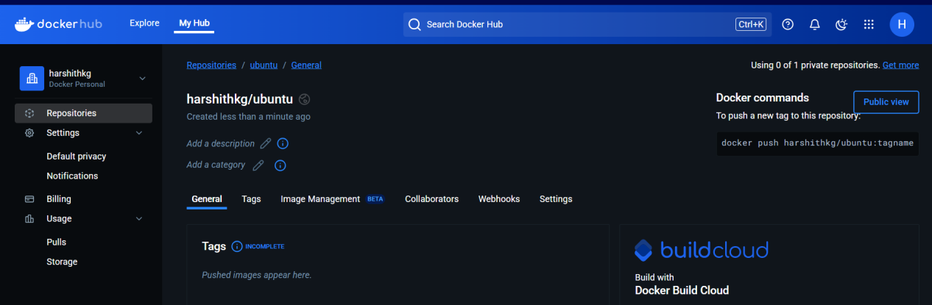

Create an image in the local.

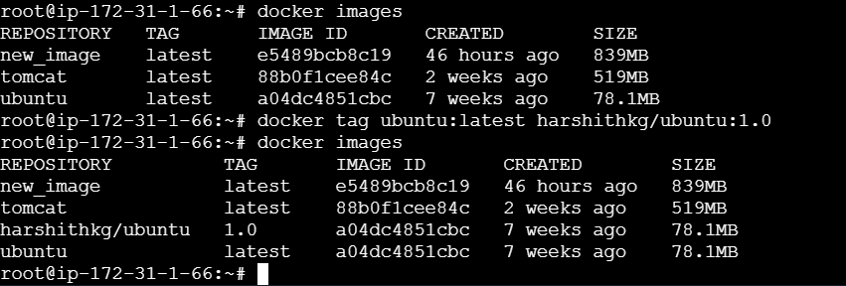

Create a Personal access token in docker hub and keep

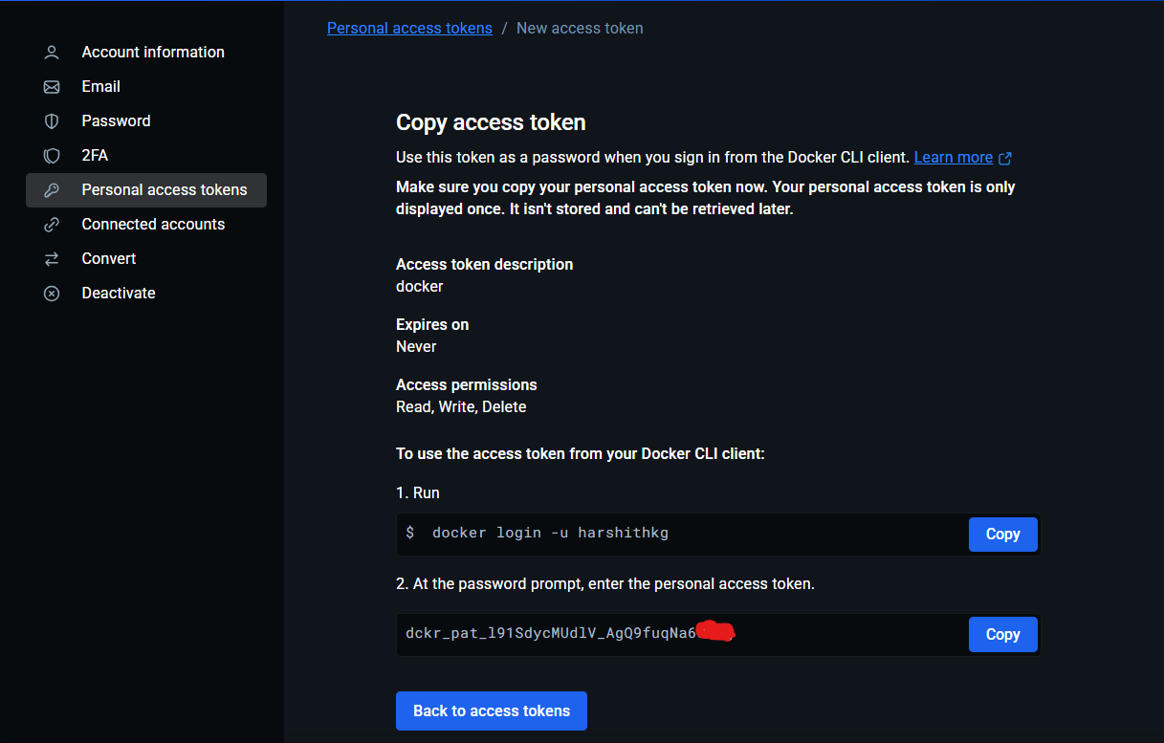

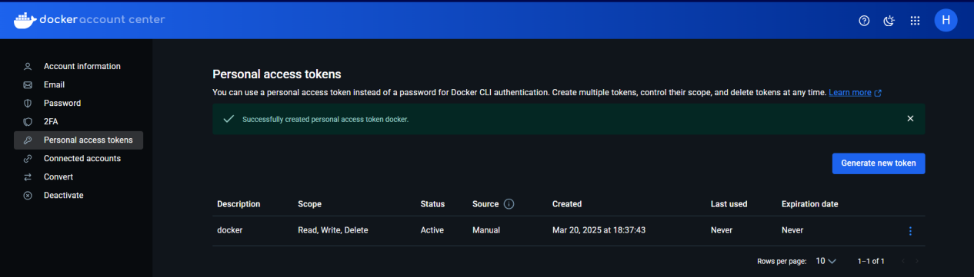

Login to docker from console using Permanent Access Token

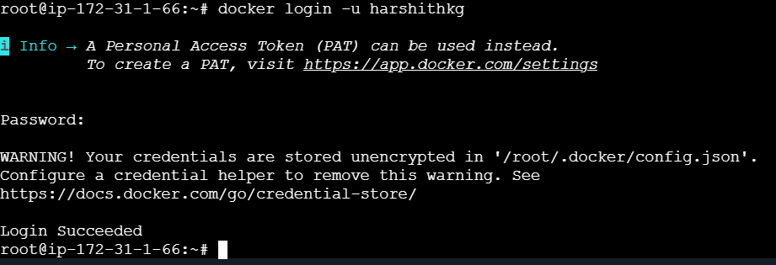

Push the images created from console to docker hub

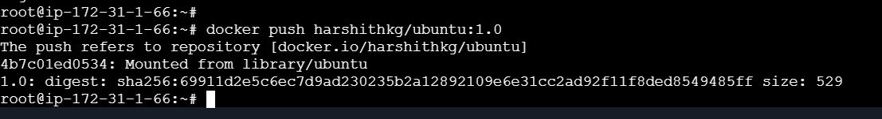

Check for the image pulled in the docker registry

